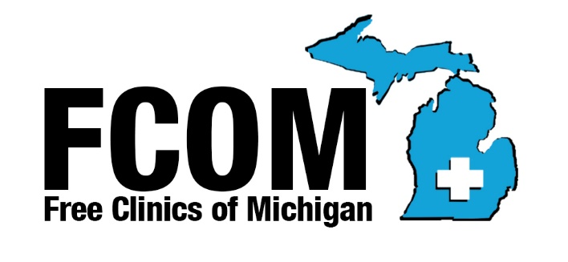

Free Clinics of Michigan
1211 Lafayette Ave. NE
Grand Rapids MI 49505
admin@fcomi.org www.fcomi.org

2020

MEMBERSHIP APPLICATION
Associate Members

Associate membership, without the right to vote or serve on the Board of Directors, is open to interested parties and organizations who support the goals of Free Clinics of Michigan.

Name |  | Click here to enter your name
Address |  |  | Number and street |  |  |  | City |  |  |  |  |  | State |  |  | Zip
Mailing Address (if different) |  |  |  |  |  | Number and street |  |  |  |  | City |  |  | State |  |  | Zip
Phone |  | Phone number |  |  |  |  |  | Fax | Fax number
E-Mail |  | Email address |  |  |  |  |  | Website |  |  |  | Website address
 | Primary Contact |  |  | Primary contact name
Phone |  | Primary contact phone |  |  |  |  |  | E-Mail |  | Primary contact E-Mail
For-Profit☐ or |  |  |  |  | Non-Profit☐ |  |  | If Non-Profit, EIN # |  |  |  |  |  |  | EIN #

Why do you want to join? How will being an Associate Member benefit Michigan’s free clinics? (Use the other side of the application if needed)
Answer here using as much space as needed.

BENEFITS OF AN FCOM ASSOCIATE MEMBERSHIP
- Notification of and participation in FCOM Meetings
- Networking opportunities with Michigan’s Free Clinics

$50.00- Half Year membership September 1 to December 31. Donations are gratefully accepted.
PLEASE MAIL COMPLETED FORM AND CHECK TO THE FCOM ADDRESS ABOVE

Signature/Position of Applicant | Insert Signature/Position |  | Date | Date

